NOTICE OF PROPOSAL
ROAD TRAFFIC REGULATION ACT 1984
LANCASHIRE COUNTY COUNCIL
(HOYLES LANE, COTTAM, PRESTON CITY) (ROAD HUMPS)

NOTICE IS HEREBY GIVEN that in accordance with Section 90A of the Highways Act 1980, Lancashire County Council propose to introduce road humps in the following locations:

- Hoyles Lane, Cottam, from a point 66 metres north east of its junction with the centreline of Sidgreaves Lane for a distance of 3 metres in a north easterly direction;
- Hoyles Lane, Cottam, from a point 152 metres north east of its junction with the centreline of Sidgreaves Lane for a distance of 3 metres in a north easterly direction;
- Hoyles Lane, Cottam, from a point 247 metres north east of its junction with the centreline of Sidgreaves Lane for a distance of 3 metres on a north easterly direction;
- Hoyles Lane, Cottam, from a point 324 metres north east of its junction with the centreline of Sidgreaves Lane for a distance of 3 metres on a north easterly direction;
- Hoyles Lane, Cottam, from a point 222 metres south west of its junction with the centreline of Applewood Road for a distance of 3 metres in a south westerly direction;
- Hoyles Lane, Cottam, from a point 124 metres south west of its junction with the centreline of Applewood Road for a distance of 3 metres in a south westerly direction;
- Hoyles Lane, Cottam, from a point 32 metres south west of its junction with the centreline of Applewood Road for a distance of 3 metres on a south westerly direction;
- Hoyles Lane, Cottam, from a point 39 metres north east of its junction with the centreline of Applewood Road for a distance of 3 metres in a north easterly direction;
- Hoyles Lane, Cottam, from a point 163 metres north east of its junction with the centreline of Applewood Road for a distance of 3 metres in a north easterly direction;
- Hoyles Lane, Cottam, from a point 87 metres south west of its junction with the centreline of Westward Close for a distance of 3 metres in a south westerly direction;
- Hoyles Lane, Cottam, from a point 9 metres south west of its junction with the centreline of Westward Close for a distance of 3 metres in a south westerly direction;
- Hoyles Lane, Cottam, from a point 72 metres north east of its junction with the centreline of Westward Close for a distance of 3 metres in a north easterly direction;
- Hoyles Lane, Cottam, from a point 172 metres north east of its junction with the centreline of Westward Close for a distance of 3 metres in a north easterly direction;
- Hoyles Lane, Cottam, from a point 64 metres north east of its junction with the centreline of Ribbleswood Chase for a distance of 3 metres in a north easterly direction;
- Hoyles Lane, Cottam, from a point 140 metres north east of its junction with the centreline of Ribbleswood Chase for a distance of 3 metres on a north easterly direction;
- Hoyles Lane, Cottam, from a point 124 metres north west of its junction with the centreline of Sandy Lane for a distance of 3 metres on a north westerly direction;
- Hoyles Lane, Cottam, from a point 250 metres north east of its junction with the centreline of Sandy Lane for a distance of 3 metres in a north easterly direction;
- Hoyles Lane, Cottam, from a point 164 metres south west of its junction with the cross roads of Tag Lane, Lightfoot Lane and Tabley Lane, for a distance of 3 metres in a south westerly direction;
- Hoyles Lane, Cottam, from a point 57 metres south west of its junction with the cross roads of Tag Lane, Lightfoot Lane and Tabley Lane, for a distance of 3 metres in a south westerly direction.

The road humps will have a maximum height not exceeding 75 millimetres, will be 3 metres long and 2.1 metres wide.

Statement of Reasons
As part of the overall Cottam development masterplan there is an aspiration to remove through traffic from Hoyles Lane. Traffic calming funded via development is proposed to be implemented to compliment a reduction in the speed limit to 20mph and so by discourage the route for through traffic. Speed cushions have been identified as the most suitable form of calming feature to have a positive impact in reducing vehicle speeds whilst retaining residential driveway access.

A copy of the relevant notice and plan, indicating the proposal may be inspected during normal office hours at the offices of the Preston City Council, PO Box 10, Town Hall, Lancaster Road, Preston, PR1 2RL and at the offices of The Director of Corporate Services, Lancashire County Council, Christ Church Precinct, County Hall, Preston PR1 8XJ, and on Lancashire County Councils Website http://www.lancashire.gov.uk/roads-parking-and-travel/roads/roadworks-and-traffic-regulation-orders/permanent.aspx. Any representations or objections (specifying the grounds on which they are made) relating to the proposal must be made in writing and should be sent to The Director of Corporate Services, Lancashire County Council, P O Box 78, County Hall, Preston PR1 8XJ or by e-mail to tro-consultation@lancashire.gov.uk quoting ref: LSG4.AFR.894.10502 before 06 December 2019.

Laura Sales, Director of Corporate Services
08 November 2019
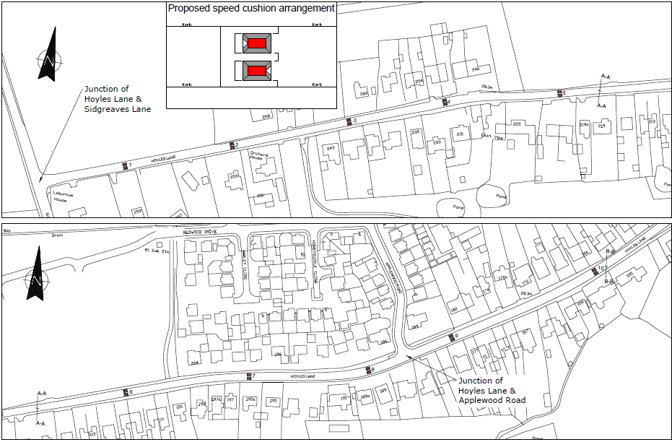
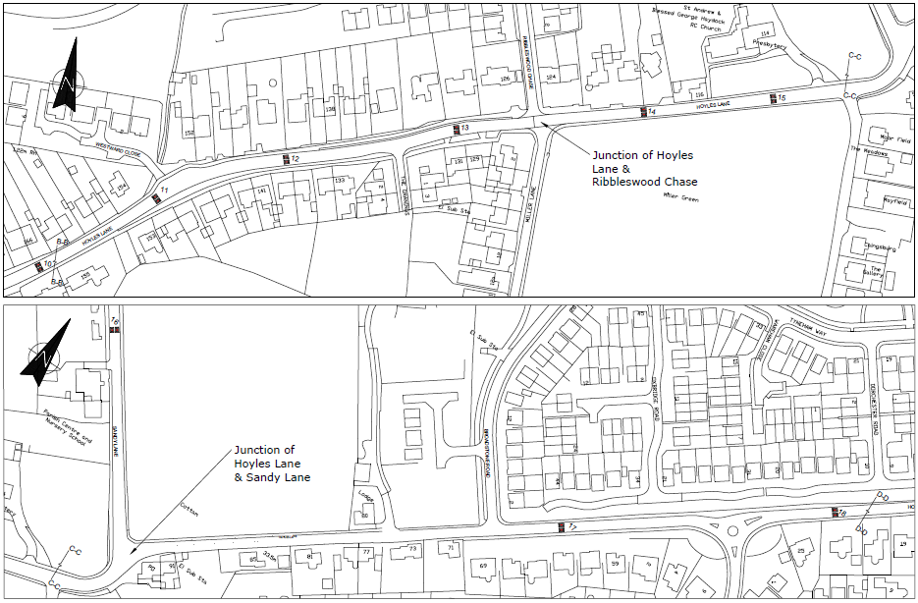
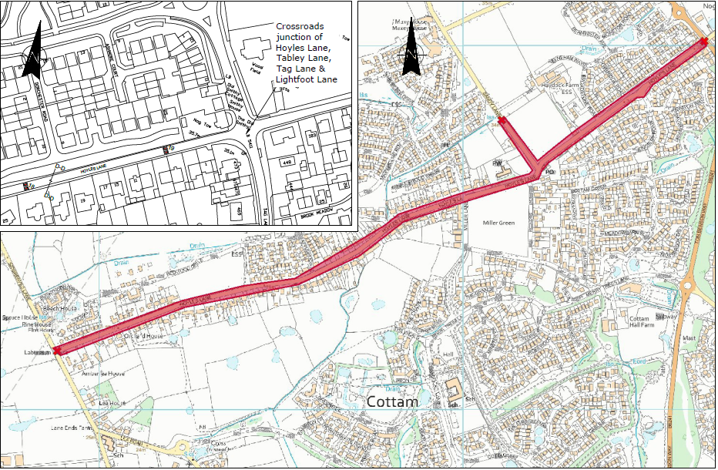
Based upon Ordnance Survey data with the permission of the Controller of Her Majesty's Stationery Office Crown Copyright Licence No 100023520 Unauthorised reproduction infringes Crown Copyright and may lead to prosecution or civil proceedings.

